Nombres:

Miguel Guarucano

Jesús Ordoñez

3.- Dada la siguiente relación Asignación que contiene información relativa a la asignación de losturnos de trabajo de los empleados de los distinoscentros de una cadena de moda:

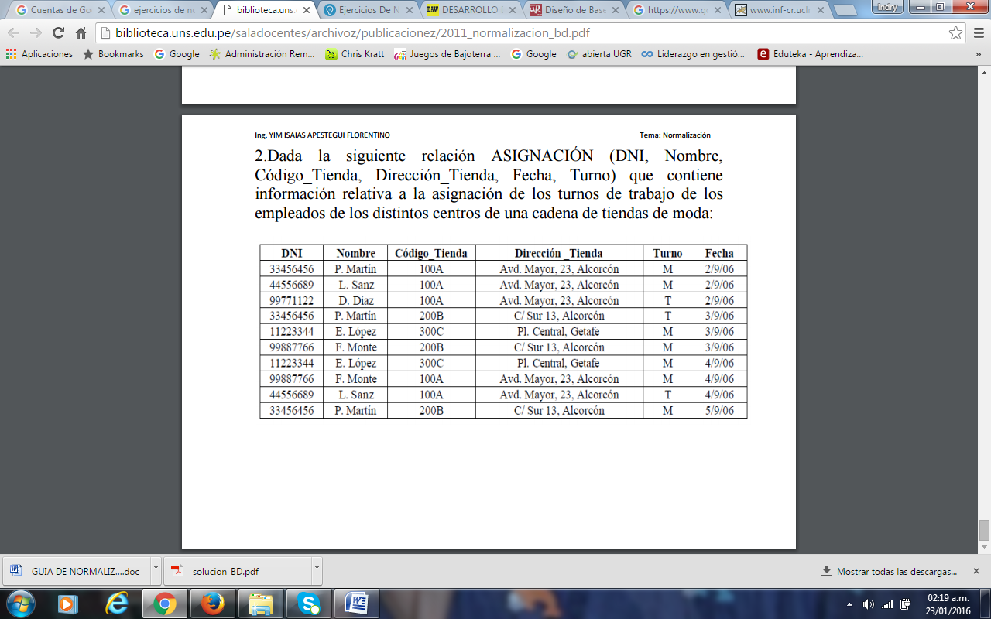

Organizando la Tabla

|  |  |  |  |  |  |
| --- | --- | --- | --- | --- | --- |
| DNI | Nombre | Codigo_Tienda | Dirección Tienda | Turno | Fecha |
| 33456456 | P. Martin | 100A | Avd. Mayor, 23. Alcorcón | M | 02/09/06 |
| 33456456 | P. Martin | 200B | C/ Sur 13, Alcorcón | T | 03/09/06 |
| 33456456 | P. Martin | 200B | C/ Sur 13, Alcorcón | M | 05/09/06 |
| 44556689 | L. Sanz | 100A | Avd. Mayor, 23. Alcorcón | M | 02/09/06 |
| 44556689 | L. Sanz | 100A | Avd. Mayor, 23. Alcorcón | T | 04/09/06 |
| 99771122 | D. Díaz | 100A | Avd. Mayor, 23. Alcorcón | T | 02/09/06 |
| 11223344 | E. López | 300C | Pl. Central, Getafe | M | 03/09/06 |
| 11223344 | E. López | 300C | Pl. Central, Getafe | M | 03/09/06 |
| 99887766 | F. Monte | 200B | C/ Sur 13, Alcorcón | M | 03/09/06 |
| 99887766 | F. Monte | 100A | C/ Sur 13, Alcorcón | M | 04/09/06 |

**1FN**

Tabla Nombre

|  |  |
| --- | --- |
| **DNI** | Nombre |
| 33456456 | P. Martin |
| 44556689 | L. Sanz |
| 99771122 | D. Díaz |
| 11223344 | E. López |
| 99887766 | F. Monte |

Tabla Tienda

|  |  |  |  |  |
| --- | --- | --- | --- | --- |
| DNI | Codigo_Tienda | Dirección_Tienda | Turno | Fecha |
| 33456456 | 100A | Avd. Mayor, 23. Alcorcón | M | 02/09/06 |
| 33456456 | 200B | C/ Sur 13, Alcorcón | T | 03/09/06 |
| 33456456 | 200B | C/ Sur 13, Alcorcón | M | 05/09/06 |
| 44556689 | 100A | Avd. Mayor, 23. Alcorcón | M | 02/09/06 |
| 44556689 | 100A | Avd. Mayor, 23. Alcorcón | T | 04/09/06 |
| 99771122 | 100A | Avd. Mayor, 23. Alcorcón | T | 02/09/06 |
| 11223344 | 300C | Pl. Central, Getafe | M | 03/09/06 |
| 11223344 | 300C | Pl. Central, Getafe | M | 03/09/06 |
| 99887766 | 200B | C/ Sur 13, Alcorcón | M | 03/09/06 |
| 99887766 | 100A | C/ Sur 13, Alcorcón | M | 04/09/06 |

**2FN**

Tabla Tienda

|  |  |
| --- | --- |
| Codigo_Tienda | Direccion_Tienda |
| 100A | Avd. Mayor, 23. Alcorcón |
| 200B | C/ Sur 13, Alcorcón |
| 300C | Pl. Central, Getafe |

Tienda-Nombre

|  |  |  |  |
| --- | --- | --- | --- |
| DNI | Codigo_tienda | Turno | Fecha |
| 33456456 | 100A | M | 02/09/06 |
| 44556689 | 100A | M | 02/09/06 |
| 99771122 | 100A | T | 02/09/06 |
| 33456456 | 200B | T | 03/0906 |
| 11223344 | 300C | M | 03/0906 |
| 99887766 | 200B | M | 03/0906 |
| 11223344 | 300C | M | 04/09/06 |
| 99887766 | 100A | M | 04/09/06 |
| 44556689 | 100A | T | 04/09/06 |
| 33456456 | 200B | M | 05/09/06 |

**3FN**

Tabla Nombre

|  |  |
| --- | --- |
| **DNI** | Nombre |
| 33456456 | P. Martin |
| 44556689 | L. Sanz |
| 99771122 | D. Díaz |
| 11223344 | E. López |
| 99887766 | F. Monte |

Tabla Tienda

|  |  |
| --- | --- |
| **Codigo_Tienda** | Direccion_Tienda |
| 100A | Avd. Mayor, 23. Alcorcón |
| 200B | C/ Sur 13, Alcorcón |
| 300C | Pl. Central, Getafe |

Tabla Turno

|  |  |
| --- | --- |
| **Código turno** | Turno |
| 01 | M |
| 02 | T |

Tabla horario

|  |  |  |  |
| --- | --- | --- | --- |
| **DNI** | **Código_tienda** | **Código_turno** | Fecha |
| 33456456 | 100A | 01 | 02/09/06 |
| 44556689 | 100A | 01 | 02/09/06 |
| 99771122 | 100A | 02 | 02/09/06 |
| 33456456 | 200B | 02 | 03/0906 |
| 11223344 | 300C | 01 | 03/0906 |
| 99887766 | 200B | 01 | 03/0906 |
| 11223344 | 300C | 01 | 04/09/06 |
| 99887766 | 100A | 01 | 04/09/06 |
| 44556689 | 100A | 02 | 04/09/06 |
| 33456456 | 200B | 01 | 05/09/06 |

Tabla_Nombre(**DNI**,nombre)

Tabla_Tienda(**Codigo_tienda**,Direccion_tienda)

Tabla_turno(**código_turno**,turno)

Tabla_horario(**DNI**,código_tienda,código_turno,fecha)